The LHCb CROP (Calorimeters Read Out Processor) board

Abstract

The aim of the LHCb CROP board is to read and treat information coming from either the ECAL or the HCAL or the PRS/SPD calorimeters. So the architecture of the board has to be thought in order to fulfil the requirements of four kinds of detectors. That’s why the CROP module will probably be designed with FPGA easily programmable for different CROP version. In order to facilitate the neighbors seeking each CROP will be associated with a whole zone of a half calorimeter.
The main and common processes are the input treatment (error detection and correction), the zero suppression and energy computing, the trigger and ADC treatments and the output formatting to the DAQ. Of course all these processes have to attend the L0 rate: 50kHz.

Contents

Introduction
A. Calorimeters………………………………………………………………… 3
B. CROP partition……………………………………………………………… 4

Specifications
A. Input format……………………………………………………………….… 5
B. Data process
1. Input validation-correction…………………………………………. 6
2. Data treatment………………………………………………………. 6
3. Output formatting…………………………………………………… 7
C. Credit Card PC…………………………………………………..…………... 8
D. Tests and debugging…………………………………………………………. 8

CROP block diagram
A. PRS/SPD version…………………………………………………………….. 8
B. ECAL/HCAL version……………………………………………………….. 9
Input treatment
A. GLINK decoding……………………………………………………………. 11
B. Block verification……………………………………………………………. 12
C. Block correction……………………………………………………………… 12
D. Event format verification……………………………………………………. 12
E. Output multiplexer…………………………………………………………… 13
F. Internal registers……………………………………………………………… 13
G. Timing characteristics………………………………….……………………. 13
H. FPGA logic resources……………………………………………………….. 14
Zero suppression and Energy computing
A. PRS/SPD version…………………………………………………………….. 14
B. ECAL/HCAL version……………………………………………………….. 15
C. FPGA RAM management…………………………………………………….16
D. Timing characteristics………………………………………………….……..16
E. FPGA logic resources………………………………………………….……...16

ANNEXES
A. I2C slave………………………………………………………………………17

REFERENCES………………………………………………………………………….. 17

Introduction

A . Calorimeters.

The CROP module has to be able to treat information coming from 4 kinds of calorimeters named ECAL (Electromagnetic Calorimeter), HCAL (Hadronic Calorimeter), SPD (Scintillator Pad Detector) and PRS (Preshower) (Fig 1).
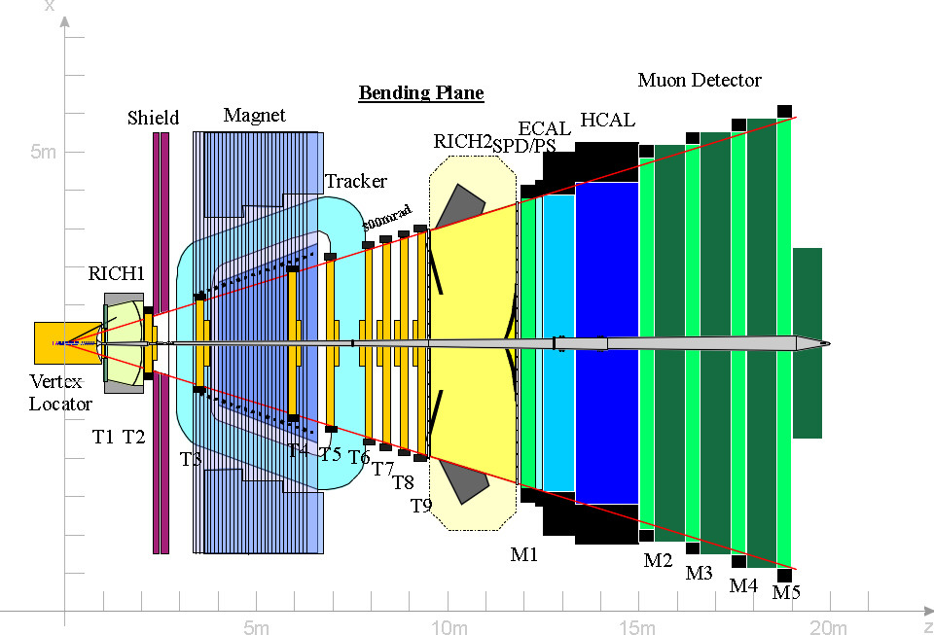

Fig 1 : ECAL,HCAL,PRS/SPD calorimeters.

A few description of the 4 calorimeters can be found below:
- SPD : plane of 6000 scintillator tiles, digital reading.
- PRS : plane of 6000 scintillator tiles, analog reading (PRS and SPD are read together).
- ECAL : 6000 “shashlik” channels, analog reading.
- HCAL : 1500 “tiles” channels (like ATLAS).

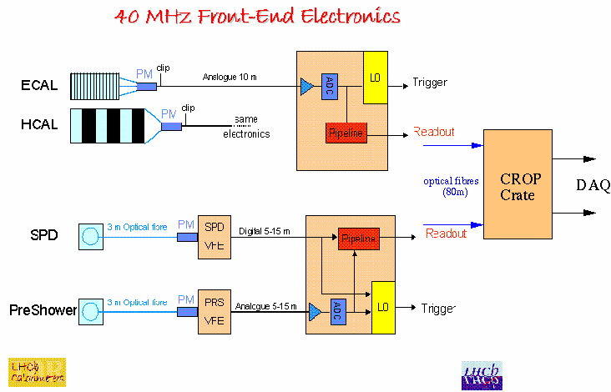
Into the measurement chain the CROP modules will be located between the front end boards (designed by the LPC and LAL) and the data acquisition (DAQ CERN) (Fig 2). The connections between them would be done with optical fibers.

Fig 2 : LHCb measurement chain.

B . CROP partition.

Each half calorimeter is divided in zones with different granularity. For example the left side of ECAL is built with 3 zones (Fig 3), each zone being read by at least 3 front end crates. Its external zone is read by 3 crates, the medium and the internal zones by 2 crates. Each front end crates contains a maximum of 16 front end boards that are connected to 32 channels each.
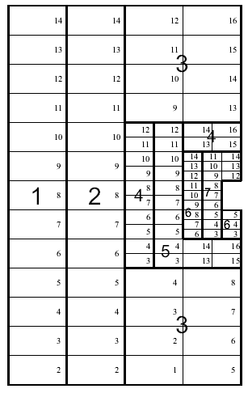

Fig 3 : ECAL left side.

To facilitate the neighbors seeking (the most delicate point of the CROP process) each CROP has to be associated with a whole zone of a half calorimeter (Fig 4). For example the external zone of the ECAL will be treated by one CROP. This zone being read by 3 crates, the associated CROP module should have 3 input optical fibers.
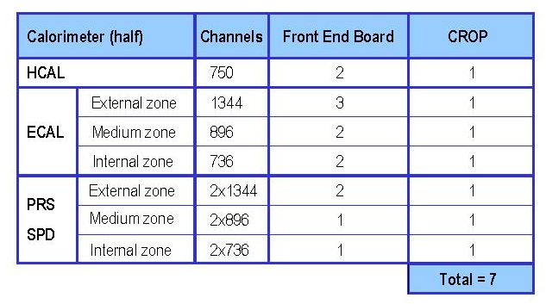In summary, for all the detectors ECAL,HCAL and PRS/SPD 14 CROP boards will be produced.
Fig 4 : CROP partition.

Specifications

A . Input format.
The information coming from the front end crates are transmitted through optical fibers of 80 meters length. LHCb experiment uses the standard GLINK protocol for the optical emitters and receivers. To treat a whole zone of a half calorimeter each CROP module should integrate a maximum of 3 GLINK receivers.
Through these optical fibers the data are transmitted in parallel with a 21 bits bus. Each event is divided in a maximum of 16 blocks that contains 34 words each (Fig 5). A channel can be identified by its arrival order in the event block. Each block is built with a header word, 32 data words and a trailer word (vertical parity of the 33 previous words). The header word contains the BX-ID and L0-ID information. Each word is built with 20 data bits (bit [19-0]) and one horizontal parity bit (bit[20]).
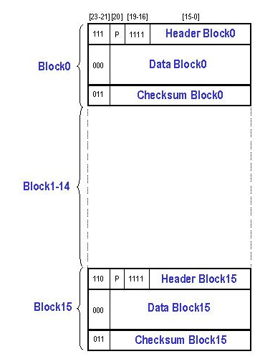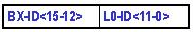To characterize header, data, trailer word or start or end of event it would be very useful to have extra tag bits (bit[23-21]). ThIS IS NOT YET INCLUDED AND should be defined later !!!

Fig 5 : Input Format.

- ECAL/HCAL data word.
The ECAL/HCAL data word contains trigger information on 8 bits (bit[19-12]) and ADC value on 12 bits (bits[11-0]) (Fig 6).

- PRS/SPD data word.
The PRS/SPD data word collects information of 2 consecutive channels. This word contains trigger information on 2 bits (SPD and PRS trigger bits) and ADC value on 8 bits.
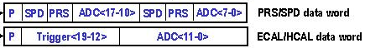

Fig 6 : Data word format.

B . Data process .
Data process can be performed in 3 consecutive steps: the input validation-correction process, the data treatment and the output formatting processes. All these processes have to attend the L0 rate so 50 KHz.

- Input validation-correction process.
This process allows to valid input block and event and to perform different controls (block and event format, L0-ID consistency and BX-ID continuity). The knowledge of the horizontal and vertical parity is indispensable to correct one error per block no more. In addition the knowledge of the location of the start and end of block and the start and end of event with extra tag bits will allow us to control the block and event format.

- Data treatment.
According the selected detector different treatments have to be performed. For each of them ADC and trigger values have to be treated in parallel.

- PRS/SPD treatment.
- ADC consideration.
The “zero suppression” is the following. If one of the 2 trigger bits (PRS or SPD) is on and if the ADC value is above a known threshold, the ADC value is kept and stretched from 8 to 11 bits (float format). Then this energy value can be transmitted to the output formatting.
We want an option with no “zero suppression” (threshold putted to zero).
- Trigger consideration.
In order to compress and to keep the trigger information 8 consecutive trigger bits are grouped together to form a 16 bits word. Then if this word is above zero it is sent to the output formatting process with the identifier of the first channel (16 bits) (Fig 7).

Fig 7 : PRS/SPD output trigger word.

- ECAL/HCAL treatment.
- ADC consideration.
The “2D zero suppression” is the following. If the ADC value is above a known threshold (one threshold per channel) the 8 neighbors of the fired cells are read (Fig 8). The energy of the selected channels is computed with the following equation E = Gain x (ADC-Pedestal). Then this integer value is converted into IEEE754 floating point format and can be transmitted to the output formatting process.
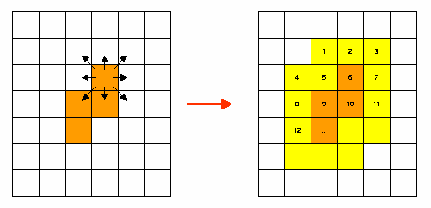
Neighbors
Fired channels

Fig 8 : Neighbors seeking.

- Trigger consideration.
The trigger value is kept if its value is above a known threshold. If 2 consecutive trigger are kept, their values are putted in the same word with the identifier of the first channel (Fig 9). Then it can be sent to the output formatting process.

Fig 8 : ECAL/HCAL output trigger word.
3 . Output formatting.
The information is transmitted to the DAQ trough an optical fiber with a SLINK protocol (Gigabit Ethernet). The output buffer is not well defined but probably will be divided in 2 distinct parts: the energy and the trigger packets. Of course these buffers include headers and trailers in order to characterize them but also to be compatible with the Gigabit Ethernet format. The output format should be 32 bits width.

-Channels identifier.
For the energy or the trigger buffer the channels have to be tagged with their own identifiers. These identifiers (Fig 9) are 16 bits width with information concerning the calorimeter, the zone, the line and column.

Calorimeter[15-14] | Zone[13-12] | Line[11-6] | Column [5-0]

Fig 9 : Channels identifier.
- Energy buffer.
In order to reduce the size of the output buffer but also to facilitate the DAQ acquisition the energy buffer can be divided in clusters. One cluster regroups information coming from one detector line.
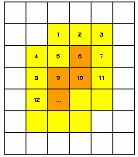Concerning the following example (Fig 10) we can see that this part of detector has 5 lines with channels on. If we consider only 3 lines (line 1,2 and 3) we can build 3 clusters (Fig 11).
Line1

Line2

Line3

Fig 10 : Part of detector with channels on.

One cluster has a header including the identifier of the first channel on and the number of fired channels. The others lines contain the energy values.

ID (1st chan.,1st line) = 1  Cluster first line  Cluster second line  Cluster third line | Chan. Number = 3
Energy value = 1
2
3
ID (1st chan.,2nd line) = 4 | Chan. Number = 4
4
5
6
7
ID (1st chan.,3rd line) = 8 | Chan. Number = 4
8
9
10
11

Fig 11 : Energy buffer.

- Trigger buffer.
The trigger buffer regroups words coming from the trigger process. The structure of these words has been defined in the Treatment process part (see above).

C . Credit card PC (CC-PC).
One CC-PC is plugged in each CROP module (Fig 12). This card is an interface between a PC and the CROP module trough an ethernet connection. It can be seen like an embedded PC on a single chip and provides a local intelligence on the CROP module. It allows monitoring, configuration, debugging and so on. This card has several local interfaces that ensure a complete control of the CROP module. Indeed the CC-PC provides 2 JTAG buses (interconnections tests and FPGA programming), 3 I2C links (registers configuration) and a simple parallel bus (memories reading and loading).

CROP module
CC-PC
JTAG bus
I2C link
Parallel bus
Ethernet (to PC)

Fig 12 : Credit Card – PC.
D . Tests and debugging.
The LHCb philosophy is that each “intelligent” boards should be able to perform selftest and debugging. In case of big problems this mode allows to test the CROP module alone and to have a rapid diagnostic. It can be performed with the CC-PC by emulating the input events, reading , analyzing and comparing the results expected.
It would also be useful to have status registers that show the detected error, the state of the CROP module …. in order to facilitate the comprehension of the possible errors.

CROP block diagram

A. PRS/SPD version (Fig 13).

- Input treatment
First of all three GLINK are plugged in the CROP module to ensure the optical-electrical conversion of the received data. One FPGA (Altera ACEX1K50 ) is associated to one GLINK for the input event validation and correction.

- Zero suppression & Energy computing.
The ADC zero suppression and the integer to float conversion are performed into one FPGA (Altera ACEX1K30). The ADC values are kept if they are above a known threshold (stored into a dedicated RAM) and if one of the 2 trigger bits is on. Then the ADCs (integer values) are converted into float format. The output data have the same format that the data coming from the input treatment but the rejected ADCs are stuck at 0.
Then the events are stored into a transition fifo waiting for the future process. This transition buffer uncouple the zero suppression from the next treatment that runs with its own speed. In order to prevent the saturation of the system a busy signal (coming from the input fifo) can be sent to the front end electronics. This signal will be used to reduce the data transmission speed at the front end electronics level.

- ADC treatment
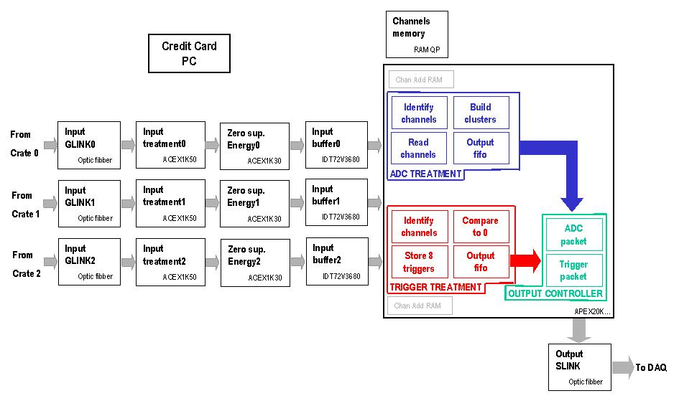The ADCs, the triggers and the output formatting processes are performed into one FPGA (APEX20K…). First, the ADCs addresses are identified (reading their appropriate values from the Chan. Add RAM) and allow to store the ADCs values into a 4 ports RAM. In parallel the ADCs addresses are stored into 3 fifos if the ADCs values are above 0. Then the chosen ADCs are read from the 4 ports RAM and organized in energy clusters. A header and a trailer are added to the event energy packet and sent to an output fifo (32 bits width) waiting for the output formatting process.

Fig 13 : PRS/SPD scheme.

- Trigger treatment.
The trigger and ADC treatment are performed in parallel. 8 consecutive trigger bits are stored into a 16 bits register. If the register value is above zero then the identifier (16 bits width) of the first channel is read (from a Chan. Add. RAM). A 32 bits register is built with the identifier (MSB) and the triggers value (LSB). A state machine manages these words coming from 3 links (using 3 input fifos ?). Then the event trigger packet is written into an output fifo with a header and a trailer (to be defined) waiting for the output formatting process.

- Output formatting (output controller).
As the trigger treatment should take less time than the ADC treatment, the output controller empty the trigger output fifo in a first time and the ADC output fifo in a second time. Then these 2 buffers are sent to the output SLINK with the appropriate Gigabit Ethernet protocol.

- Output SLINK.
An output SLINK is used to ensure the electrical-optical conversion for the DAQ transmission.

B. ECAL/HCAL version (Fig 14).

- Input treatment.
See PRS/SPD/Treatment.

- Zero suppression & Energy computing.
The ADC and the trigger zero suppression and the ADCs energy computing are performed into one FPGA (Altera ACEX1K30). The ADC and the trigger values are kept if they are above a known threshold (stored into dedicated RAMs). Then energy is calculated reading the channels pedestal and gain from one RAM. The output data have the same format that the data coming from the input treatment but the rejected ADCs are stuck at 0.

- ADC treatment.
The ADCs, the triggers and the output formatting processes are performed into one FPGA (APEX20K…).
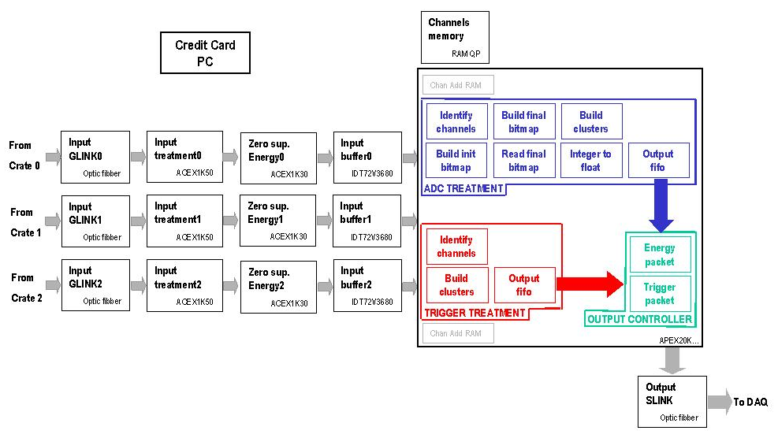First, the ADCs addresses are identified (reading their appropriate values from the Chan. Add RAM) and their values are stored into a 4 ports RAM. In parallel the ADCs addresses are stored into fifo if their values are above 0. These fifos are read to build the initial bitmap (kind of pixels representing the detector channels on) and the final bitmap (channels on with their neighbors). The final bitmap is analyzed and the chosen ADCs values are read from the 4 ports RAM and organized in ADC clusters. Then the energy is converted to the IEE754 format. A header and a trailer are added to the energy packet and sent to an output fifo waiting for the output formatting process.

Fig 14 : ECAL/HCAL scheme.

- Trigger treatment.
The first trigger value is compared to 0 and its identifier is extracted from the Chan. Add RAM. A 32 bits register is filled with the identifier (16 MSB) and the trigger value (bit[14-8]). Then the second trigger value is compared to 0. If the comparison is OK the 8 LSB of the 32 bits register takes the trigger value. If the comparison failed the 8 LSB remain null. A state machine manages these words coming from 3 links (using 3 input fifos ?) and send them to an output fifo. There the event trigger packet is written into that output buffer with a header and a trailer (to be defined).

- Output formatting (output controller).
See PRS/SPD treatment.

- Output SLINK.
See PRS/SPD treatment.

Input treatment

The CROP module needs an input treatment to check the good transmission through the optical links or to check that no data have been corrupted (SEU) at the front end level during the L0 latency.
This treatment is performed into a FPGA (ACEX1K50) (Fig 15) before the zero suppression and energy computing. As the CROP module read information coming from 3 front end crates, 3 of these FPGA are necessary. For this presentation we suppose that the front end electronics provides extra bits to tag the start-end of block or the start-end of event. We also suppose there is no corruption on these tag bits. As we can see (Fig 15) input treatment contains many steps (GLINK verification, block verification, block fifo …) that are described below. This treatment runs at 40Mhz with pipelined operations except 2 transition cycles (50 ns long).

A. GLINK decoding.

As the GLINK protocol is not yet known this part will be detailed later !!!

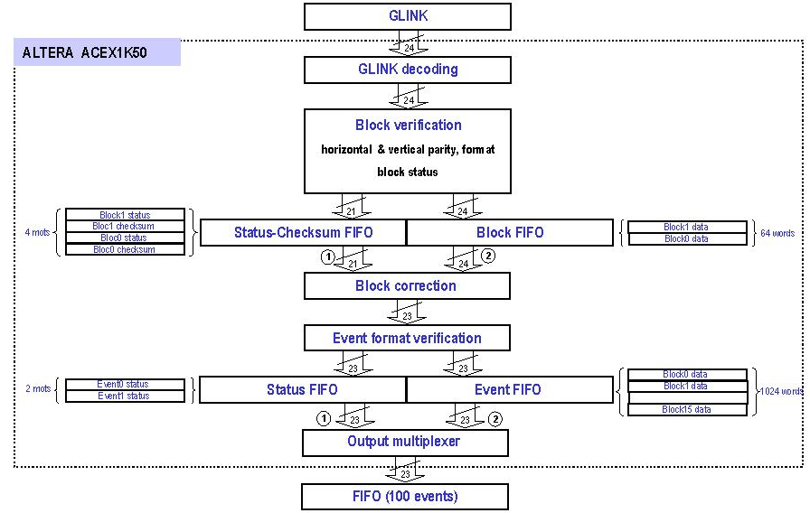
Fig 15 : Input treatment scheme.

B. Block verification.
This verification can be divided in the following steps:
- Compute and check the block format.
- Compute and check the horizontal parity bit for each word.
- Compute and check the vertical parity for the whole block.
- Build the block status (Fig 16).
- Write the block status into a transition fifo (Status-Checksum fifo).
- Build the horizontal error mask (horizontal position of the corrupted bit).
- Write the horizontal error mask into a transition fifo (Status-Checksum fifo).
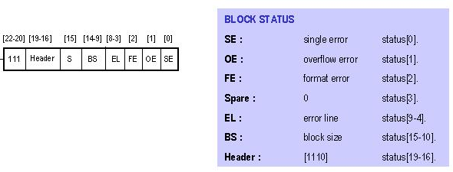 - Write the block to a transition fifo (Block fifo).

Fig 16 : Block status description.
C. Block correction.
This verification can be divided in the following steps:
- Extract two words (status + horizontal error mask) from the Status-Checksum fifo.
- Empty the Block fifo.
- Correct single bit corrupted knowing the horizontal and the vertical position of the word .
- Send the block status first and the whole data block to the next process.

D. Event format verification.
For each event this process can be divided in the following steps:
Compute and check the event format.
Compute and check the block continuity (BX-ID = BlockID increasing).
Check the L0-ID consistency (L0-ID = EventID constant).
Build the event status (Fig 17).
Write the event status into a transition fifo (Status fifo).
Write the event into a transition fifo (Event fifo).
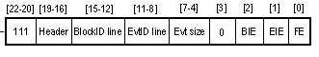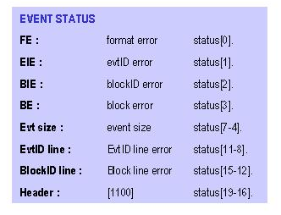
Fig 17 : Event status description.

E. Output multiplexer.
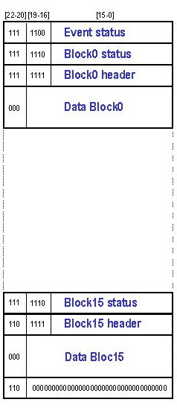This part sends the whole event to the external transition fifo. It sends the event status, the whole event and a trailer word (0). So after validation and correction the output event is the following (Fig 18).

Fig 18 : Corrected output event.

F. Internal registers.
The input treatment contains 10 registers managed through the I2C bus (Fig 19). [See annex A].

Subaddress  Reset: [0]:general  [1]:block correction  [2]:internal registers  [4]:fifos  State: [0]:block verification  [1]:block correction  Fifo flags [1-0]:empty/full block fifo  [3-2]:empty/full block-status fifo  [5-4]:empty/full event fifo  [7-5]:empty/full event-status fifo | Register type | Access
0 | Reset | W
1 | State | R
2 | Event size[0-15] | W/R
3 | Fifos flags | R
4 | Single parity error counter | R
5 | Overflow parity error counter | R
6 | Block format error counter | R
7 | Event format error counter | R
8 | BX-ID error counter | R
9 | L0-ID error counter | R

Fig 19 : Internal registers.
G. Timing characteristics.
As we have seen before the different processes are pipelined processes. The output corrected event is ready 557 cycles after the incoming event (in case of a 544 words event we have to empty the internal event fifo to put the event status first. This operation takes 544 cycles). As we add an extra event status and an extra end of event to the output corrected event we have 547 cycles between 2 output events. If the event input runs at 40Mhz the maximum input event frequency is 73.529 kHz instead of 73.126 for the maximum output event frequency.

H. FPGA logic resources.
- Logic resources : 31%.
- EAB (Embedded Array block = internal memory) : 76% (10 among 10).
- Estimated speed (with no in/output pins constraints) : ACEX1K50TC144-1 : 90Mhz.
ACEX1K50TC144-2 : 73Mhz.
ACEX1K50TC144-3 : 53Mhz.
We can note that we use the whole EAB FPGA resources whereas we have big margin with the logic resources. This allows us to implement extra logic further (GLINK decoding is not yet implemented). For example if we want a CROP self test we will need to choose the event from the GLINK or from an external RAM managed by the Credit Card. In that case this multiplexer will be implemented inside this FPGA.

Zero suppression & Energy computing

One of the principal goal of the CROP module is to perform the triggers and ADCs zero suppression and the energy computing. This treatment is performed into a FPGA (ACEX1K30) before the input buffer and runs at input 40Mhz frequency. As the CROP module reads information coming from 3 front end crates, 3 of these FPGA are necessary. As the PRS/SPD and the ECAL/HCAL zero suppression and energy computing are different two versions will be designed.

A. PRS/SPD version.
The PRS/SPD version is designed with three parallel paths (Fig 20): the ADC process, the trigger and the header/trailer words pipeline.

- ADC zero suppression and integer to float conversion.
The ADC zero suppression is a simple comparator between the ADC value and the ADC threshold read from the internal ADC threshold RAM. The internal RAM address is generated by a counter cleared by the start and the end of event and increased each time that the incoming information is a data information. Then the ADC value is kept if its value is above its threshold . In the contrary its value is stuck at 0.
The second step is to convert the ADC value (8 bits) into a float format (10 bits). For the moment the method is to read the correct float value corresponding to the ADC value. This process could may be done with two simple shifts (TO BE ASKED TO THE PRS/SPD FRONT END PEOPLE).
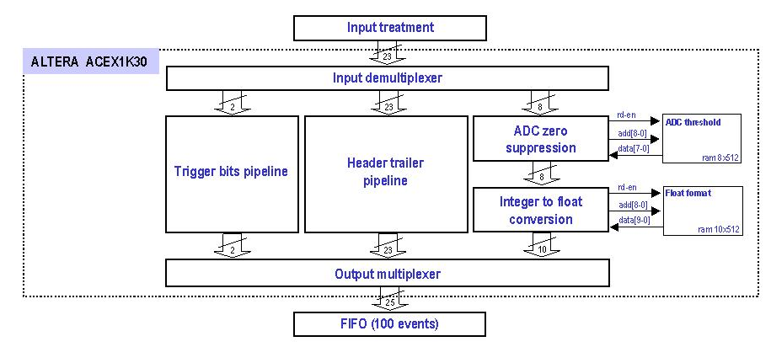

Fig 20 : PRS/SPD zero suppression.

- Trigger and header/trailer word pipeline.
In order to keep the start and end of block/event and to preserve the input format the header/trailer words are to be pipelined during the ADC, trigger zero suppression and the energy computing.

- Output multiplexer.
This stage is a synchronous multiplexer that sends the header/trailer words or the data words (ADC + trigger bits) to the output external transition fifo on a 25 bits bus. It allows to build the output block in order to preserve the incoming data format.

B. ECAL/HCAL version.
The ECAL/HCAL version is designed with three parallel paths (Fig 21): the ADC process, the trigger process and the header/trailer words pipeline.

- ADC zero suppression and energy computing.
The ADC zero suppression is a simple comparator between the ADC value and the ADC threshold read from the internal ADC threshold RAM. The internal RAM address is generated by a counter cleared by the start and the end of event and increased each time that the incoming information is a data information. Then the ADC value is kept if its value is above its threshold . In the contrary its value is stuck at 0.
The energy is calculated with the following simple formula: E = Gain x (ADC - Pedestal). The Gain and the pedestal are read from the ADC gain-pedestal RAM. The gain and the pedestal are stored into the same RAM word (Gain = bits[15-12], Pedestal = bits[11-0]).

- Trigger zero suppression.
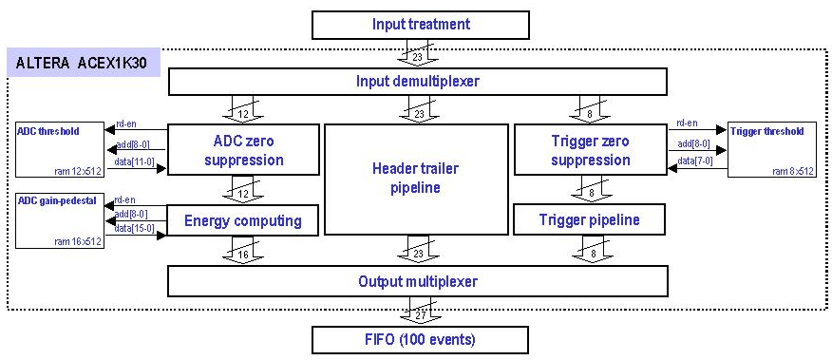The Trigger zero suppression is the same that for the ADC. The Trigger zero suppression is a simple comparator between the trigger value and the Trigger threshold read from the internal ADC threshold RAM. The internal RAM address is generated by a counter cleared by the start and the end of event and increased each time that the incoming information is a data information. Then the trigger value is kept if its value is above its threshold. In the contrary its value is stuck at 0.
The second stage is the trigger pipeline. It is necessary because the trigger process is performed in less cycles than the ADC process.

Fig 21 : ECAL/HCAL zero suppression and energy computing.

- Header/trailer word pipeline.
In order to keep the start and end of block/event and to preserve the input format the header/trailer words are to be pipelined during the ADC, trigger zero suppression and the energy computing.

- Output multiplexer.
This stage is a synchronous multiplexer that sends the header/trailer words or the data words (ADC + trigger bits) to the output external transition fifo on a 27 bits bus. It allows to build the output block in order to preserve the incoming data format.

C. FPGA RAM management.
The internal FPGA RAMs are dual port RAM with two distinct read or write interfaces (address, data, read enable, write enable). This mode allows to perform writing and reading access at the same time (Fig 22). These two ports are synchronous ports. The data are ready onto the internal RAM data bus 2 cycles after a read access.
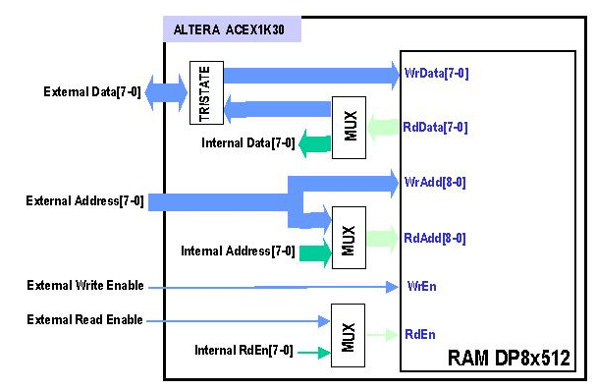The LHCb philosophy is that each element seen by the Credit Card PC (RAM, registers) must have read and write access in order to control each operation. So first of all the FPGA RAMs have to be configured and read back through an external interface (Credit Card PC). In a second time the internal FPGA logic resources have to read RAMs data to perform internal processes (zero suppression, energy…). That is why the write RAM port is only accessed by the external interface and the read RAM port is accessed by the Credit card PC but also by the internal FPGA logic resources. So we need to manage the read RAM interface (data, address, read enable) with a synchronous multiplexer. Obviously the internal FPGA processes cannot read the RAM data while the Credit Card PC performs a read RAM access.

Fig 22 : FPGA RAM management.

D. Timing characteristics.
As we have seen before the different processes are pipelined processes and does not take time. The output zero suppressed data are ready 11 cycles after the incoming data (8 cycles for the 2 RAM read accesses, 2 cycles for the zero suppression and the energy computing or the integer to float conversion and 1 cycle for the output multiplexer.
We can also note that when the Credit Card PC performs a read RAM access the RAM data are ready 4 cycles after the read enable (2 cycle for the RAM access, 1 cycle for the input RdAdd synchronous multiplexer, 2 cycles for the RAM output read port, 1cycle for the output RdData synchronous multiplexer) (see Fig 22).

E. FPGA logic resources.
- Logic resources : 33%.
- EAB (Embedded Array block = internal memory): 75% (5 among 6).
- Estimated speed (with no in/output pins constraints) : ACEX1K30TC144-1 : 80Mhz.
ACEX1K30TC144-2 : 65Mhz.
ACEX1K30TC144-3 : 47Mhz.
We can note that we use the whole EAB FPGA resources whereas we have big margin with the logic resources. This allows us to implement extra logic further.
ANNEXES

A. I2C slave.
The I2C slave (Fig A-1) can be implemented in FPGA to manage internal registers with a simple serial protocol through the Credit Card. The I2C interface needs only 3 signals : a Reset input (Rst), an open collector/drain Clock input (SCL), an open collector/drain Data bi-directional in/output (SDA). Each I2C slave has also their hard coded address (I2CslaveAdd) bus on 7 bits.
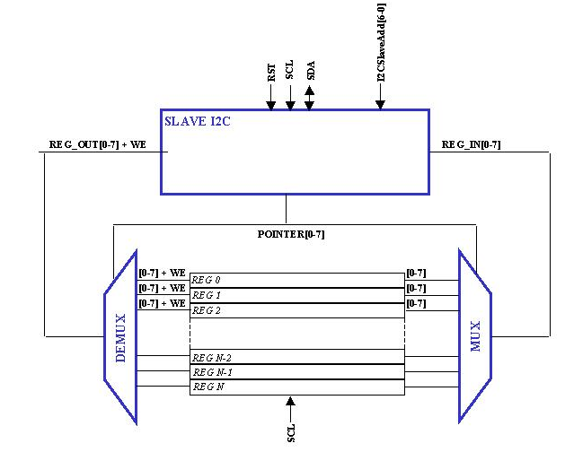The designed I2C slave allows to access up to 127 I2C slaves and 255 internal registers (8 bits) in 2 steps. The first step is to write the I2C pointer value at the I2CSlaveAdd address. The second step is to read or write the chosen internal register at the (I2CslaveAdd+1) address.
Fig A-1 : I2C slave.

PS : If we want to manage these internal registers in only 1 step we could not access up to 255 registers and the design will have few changes. If we want to access up to 8 I2C slave and 16 internal registers the I2C address frame could be the following (bit[6-4] : I2C slave address, bit[3-0] : subaddress of the internal registers.

REFERENCES

Credit Card PC : http://lhcb-comp.web.cern.ch/lhcb-comp/ECS/CCPC/default.htm
I2C specifications : http://www.semiconductors.philips.com/buses/i2c/

