- Equipment necessary for test
Test and adjustment procedures for the L.O. distribution board at 6.25 MHz
- RF spectrum analyser HP4395A or equivalent
- 1 synthesised function generator Stanford Research Systems DS345 or equivalent
- 1 digital oscilloscope with 1 probe or DC voltmeter with 0.1 mV resolution
- Adjustments
Note : All outputs must be terminated with a 50 Ω load.
- DC Offset
- The generator is connected to the « IN LO » input : sine wave, 6,25 MHz, 0 dBm amplitude.
- The probe of the oscilloscope is connected to the « DC offset point » on the CLC520 integrated circuit.

Adjust the potentiometer P2 to cancel the DC offset.
- Output level
Connect one output to the spectrum analyser or the oscilloscope (50 Ω).

- Adjust the potentiometer P1 on the board to set the output level at 0 dBm (632 mVpp with the oscilloscope).
- Check the DC offset and re-adjust it if necessary.
- Return to the beginning if necessary.
- To tune your board accurately use the front potentiometer

See the implantation schematic of the board on next page.

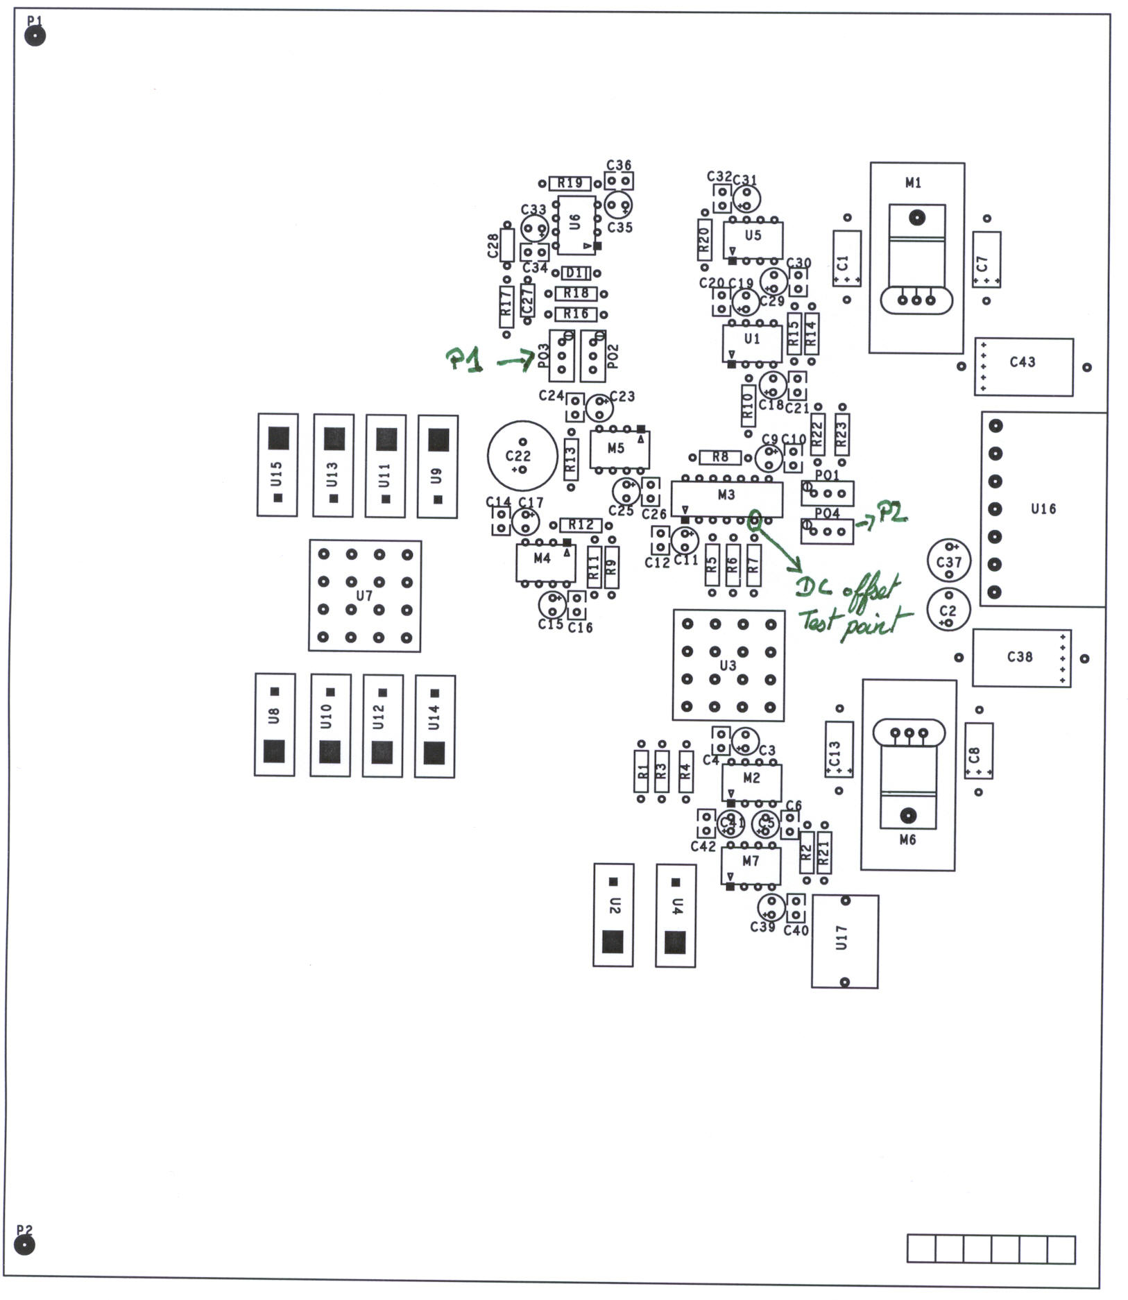
- Noise mesurements

- Electronic noise
Connect the input with the Stanford generator at 6.27 MHz.
Connect a 50 Ohms adapter on each output of the board, except on one output. With the spectrometer on noise format, mesure the noise at 1MHz.

b. Phase noise

LO BOARD

Stanford Generator
6.27 MHz +6 dBm

-6dBm

Analyser
A
B
DAC
Output
50 Ohms
INPUT

Use the spectrometer as a network analyser in phase format, then perform the tranfer function between the Output and the Input of the stanford generator.
Perform this operation twice on the two channels of the network analyser, then use the data hold menu to take the minimun value on the first channel and the maximum value on the second channel.

To mesure the jitter of phase, you have to calcul the difference between the minimum and the maximum.

